# Tugas Pemrograman Berbasis Objek



**Muhamad Salman Adhim Baqy**

**A11.2020.12641**

**Fakultas Ilmu Komputer**

**Program Studi Teknik Informatika**

**Universitas Dian Nuswantoro**

**2022**

1. 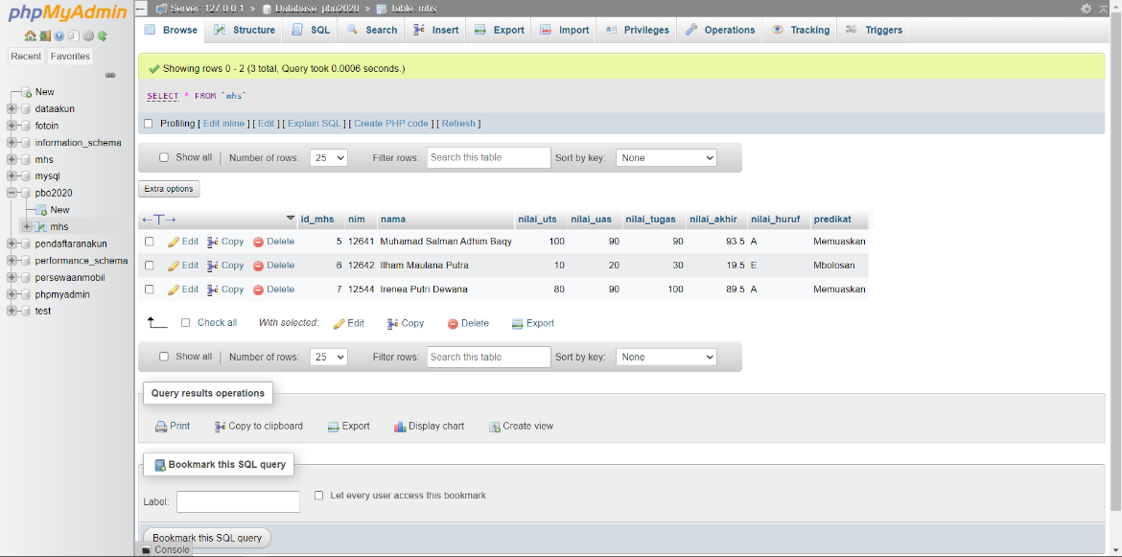Membuat Database.
2. Koneksikan database ke aplikasi yang akan dibuat.

|  |
| --- |
| /*  * To change this license header, choose License Headers in Project Properties.  * To change this template file, choose Tools | Templates  * and open the template in the editor.  */  package siakad;  import com.mysql.jdbc.Connection;  import java.sql.DriverManager;  import java.sql.SQLException;  import java.util.logging.Level;  import java.util.logging.Logger;  import javax.swing.JOptionPane;  /**  *  * @author adhim  */  public class DBConnection {  public Connection getConnection(){  Connection con = null;  try {  con = (Connection) DriverManager.getConnection("jdbc:mysql://localhost/pbo2020", "root", "");  JOptionPane.showMessageDialog(null, "Koneksi Sukses");  } catch (SQLException ex) {  Logger.getLogger(DBConnection.class.getName()).log(Level.SEVERE, null, ex);  }  return con;  }  } |

1. Membuat tampilan depan aplikasi

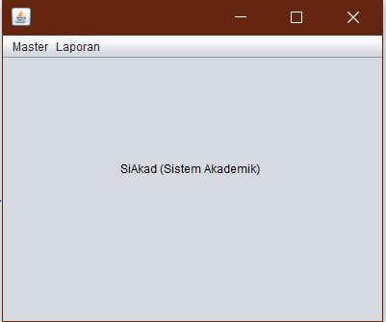

Source Code Depan.java:

|  |
| --- |
| private void dataMahasiswaActionPerformed(java.awt.event.ActionEvent evt) {  try {  // TODO add your handling code here:  new FormNilaiMhs().setVisible(true);  dispose();  } catch (SQLException ex) {  Logger.getLogger(Depan.class.getName()).log(Level.SEVERE, null, ex);  }  } |

1. Membuat Method

Mhs.java

|  |
| --- |
| /*  * To change this license header, choose License Headers in Project Properties.  * To change this template file, choose Tools | Templates  * and open the template in the editor.  */  package siakad;  /**  *  * @author adhim  */  public class Mhs implements Nilai {  public String nim, nama;  double vUts, vUas, vTugas;  double pUts, pUas, pTugas;  double nilaiAkhir;  char nHuruf;  String predikat;    //konstruktor  public Mhs(String nim, String nama, double vUts, double vUas, double vTugas){  this.nim = nim;  this.nama = nama;  this.vUts = vUts;  this.vUas = vUas;  this.vTugas = vTugas;  }    public double uts(){  return vUts * 35/100;  }    public double uas(){  return vUas * 35/100;  }    public double tugas(){  return vTugas * 30/100;  }    public double nilaiAkhir(){  return uts() + uas() + tugas();  }  @Override  public char getNilHuruf(double nilaiAkhir) {  if(nilaiAkhir >= 85.0){  nHuruf = 'A';  }else if(nilaiAkhir >= 70.0 && nilaiAkhir < 85.0){  nHuruf = 'B';  }else if(nilaiAkhir >= 60.0 && nilaiAkhir < 70.0){  nHuruf = 'C';  }else if(nilaiAkhir >= 40.0 && nilaiAkhir < 60.0){  nHuruf = 'D';  }else{  nHuruf = 'E';  }  return nHuruf;  }  @Override  public String getPredikat(char nHuruf) {  switch(nHuruf){  case 'A':  predikat = "Memuaskan";  break;  case 'B':  predikat = "Baik";  break;  case 'C':  predikat = "Cukup";  break;  case 'D':  predikat = "Dongo";  break;  case 'E':  predikat = "Mbolosan";  break;  }  return predikat;  }    } |

1. Membuat tampilan Data Mahasiswa serta Fungsi CRUD.

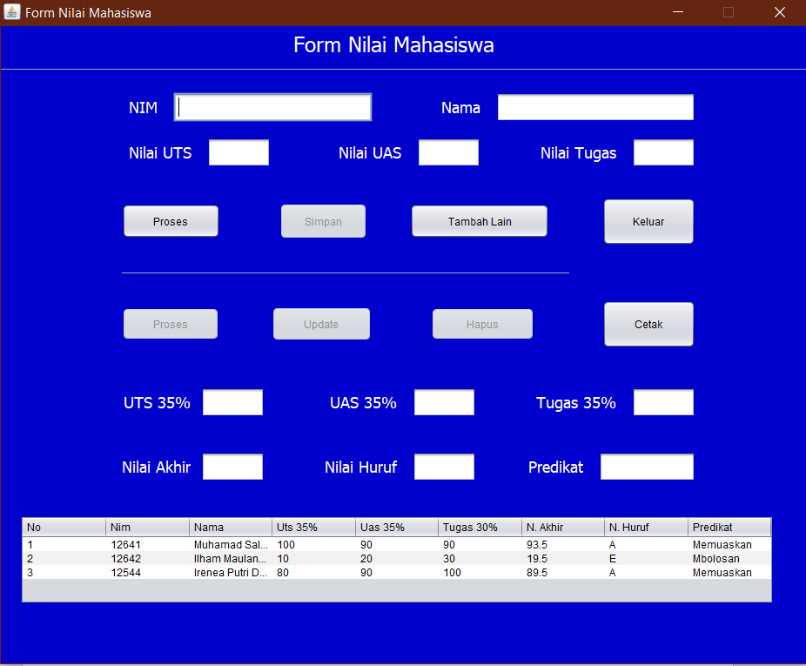

Source Code FormNilaiMhs.java:

|  |
| --- |
| extends javax.swing.JFrame {  DefaultTableModel tabel1;  Object[] list_mhs = new Object[9];  int x = 0; // int untuk nomor ascending  DBConnection dbCon = new DBConnection();  Connection con = dbCon.getConnection();    /**  * Creates new form FormNilaiMhs  */  public FormNilaiMhs() throws SQLException {  initComponents();    tabel1 = new DefaultTableModel();  tabel.setModel(tabel1);  tabel1.addColumn("No"); tabel1.addColumn("Nim");  tabel1.addColumn("Nama"); tabel1.addColumn("Uts 35%");  tabel1.addColumn("Uas 35%"); tabel1.addColumn("Tugas 30%");  tabel1.addColumn("N. Akhir"); tabel1.addColumn("N. Huruf");  tabel1.addColumn("Predikat");    setResizable(false); //tdk dapat diperbesar    //tidak bisa diketik  uts35.setEditable(false);  uas35.setEditable(false);  tugas35.setEditable(false);  nUts2.setEditable(false);  nUas2.setEditable(false);  nTugas2.setEditable(false);    //tidak bisa diklik  simpan.setEnabled(false);  update.setEnabled(false);  hapus.setEnabled(false);  proses1.setEnabled(false);    tampilkanDiTabel();  }  public void tampilkanDiTabel() throws SQLException{  ArrayList[] list = getMhsList();  DefaultTableModel model = (DefaultTableModel)tabel.getModel();    Object[] row = new Object[9];  for(int i = 0; i < list.length; i++){  row[0] = i + 1;  row[1] = list[i].get(0); row[2] = list[i].get(1);  row[3] = list[i].get(2); row[4] = list[i].get(3);  row[5] = list[i].get(4); row[6] = list[i].get(5);  row[7] = list[i].get(6); row[8] = list[i].get(7);    model.addRow(row);  }    }    public void kosongkanTextField(){  nim.setText(""); nama.setText("");  nUts.setText(""); nUas.setText(""); nTugas.setText("");  uts35.setText(""); uas35.setText(""); tugas35.setText("");  nUts2.setText(""); nUas2.setText(""); nTugas2.setText("");  }    public void prosesHitungNilai(){  try{  String ni = nim.getText();  String na = nama.getText();  Double ts = Double.parseDouble(nUts.getText());  Double as = Double.parseDouble(nUas.getText());  Double tgs = Double.parseDouble(nTugas.getText());    Mhs m = new Mhs(ni, na, ts, as, tgs);  uts35.setText("" + m.uts()); uas35.setText("" + m.uas());  tugas35.setText("" + m.tugas());  nUts2.setText("" + m.nilaiAkhir());  nTugas2.setText("" + m.getPredikat(m.getNilHuruf(m.nilaiAkhir())));  nUas2.setText("" + m.getNilHuruf(m.nilaiAkhir()));    simpan.setEnabled(true);  }catch(NumberFormatException e){  JOptionPane.showMessageDialog(null, "Inputan Anda Kosong", "Warning", JOptionPane.WARNING_MESSAGE);  }  }    public void kosongkanTabel(){  DefaultTableModel model = (DefaultTableModel)this.tabel.getModel();  model.setRowCount(0);  }    public void terpilih(int index) throws SQLException{  ArrayList[] list = getMhsList();  nim.setText((String) list[index].get(0));  nama.setText((String) list[index].get(1));  nUts.setText((String) list[index].get(2).toString()); // karena double  nUas.setText((String) list[index].get(3).toString());  nTugas.setText((String) list[index].get(4).toString());    proses.setEnabled(false);  simpan.setEnabled(false);  }    public ArrayList[] getMhsList() throws SQLException{  String queryCount = "SELECT COUNT(*) AS c FROM mhs";  Statement st;  ResultSet rsCount, rs;    st = con.createStatement();  rsCount = st.executeQuery(queryCount);  int sizeTable = 0;    while(rsCount.next()){  sizeTable = rsCount.getInt("c");  //panggil alias c dari querycount  }    ArrayList[] mhsList = new ArrayList[sizeTable];    String query = "SELECT * FROM mhs";  rs = st.executeQuery(query);  int x = 0;  while(rs.next()){  mhsList[x] = new ArrayList<>();  mhsList[x].add(rs.getString("nim")); mhsList[x].add(rs.getString("nama"));  mhsList[x].add(rs.getString("nilai_uts")); mhsList[x].add(rs.getString("nilai_uas"));  mhsList[x].add(rs.getString("nilai_tugas")); mhsList[x].add(rs.getString("nilai_akhir"));  mhsList[x].add(rs.getString("nilai_huruf")); mhsList[x].add(rs.getString("predikat"));  x++;  }    return mhsList;  }      private void nimActionPerformed(java.awt.event.ActionEvent evt) {  // TODO add your handling code here:  }  private void namaActionPerformed(java.awt.event.ActionEvent evt) {  // TODO add your handling code here:  }  private void nUtsActionPerformed(java.awt.event.ActionEvent evt) {  // TODO add your handling code here:  }  private void nUasActionPerformed(java.awt.event.ActionEvent evt) {  // TODO add your handling code here:  }  private void nTugasActionPerformed(java.awt.event.ActionEvent evt) {  // TODO add your handling code here:  }  private void uts35ActionPerformed(java.awt.event.ActionEvent evt) {  // TODO add your handling code here:  }  private void uas35ActionPerformed(java.awt.event.ActionEvent evt) {  // TODO add your handling code here:  }  private void tugas35ActionPerformed(java.awt.event.ActionEvent evt) {  // TODO add your handling code here:  }  private void nUas2ActionPerformed(java.awt.event.ActionEvent evt) {  // TODO add your handling code here:  }  private void nTugas2ActionPerformed(java.awt.event.ActionEvent evt) {  // TODO add your handling code here:  }  private void nUts2ActionPerformed(java.awt.event.ActionEvent evt) {  // TODO add your handling code here:  }  private void prosesActionPerformed(java.awt.event.ActionEvent evt) {  // TODO add your handling code here:  prosesHitungNilai();  }  private void keluarActionPerformed(java.awt.event.ActionEvent evt) {  // TODO add your handling code here:  dispose();  }  private void proses1ActionPerformed(java.awt.event.ActionEvent evt) {  // TODO add your handling code here:  prosesHitungNilai();  update.setEnabled(true);  simpan.setEnabled(false);  }  private void tabelMouseClicked(java.awt.event.MouseEvent evt) {  // TODO add your handling code here:  int index = tabel.getSelectedRow();  try {  terpilih(index);  } catch (SQLException ex) {  Logger.getLogger(FormNilaiMhs.class.getName()).log(Level.SEVERE, null, ex);  }  proses1.setEnabled(true);  hapus.setEnabled(rootPaneCheckingEnabled);  }  private void tambahLainActionPerformed(java.awt.event.ActionEvent evt) {  // TODO add your handling code here:  kosongkanTextField();  proses.setEnabled(true);    uts35.setEditable(false); uas35.setEditable(false); tugas35.setEditable(false);  nUts2.setEditable(false); nUas2.setEditable(false); nTugas2.setEditable(false);    simpan.setEnabled(false); update.setEnabled(false);  hapus.setEnabled(false); proses1.setEnabled(false);    }  private void simpanActionPerformed(java.awt.event.ActionEvent evt) {  try {  // TODO add your handling code here:  PreparedStatement ps = con.prepareStatement("INSERT INTO mhs(nim, nama, nilai_uts, nilai_uas, nilai_tugas, nilai_akhir, nilai_huruf, predikat) VALUES (?, ?, ?, ?, ?, ?, ?, ?)");  ps.setString(1, nim.getText()); ps.setString(2, nama.getText());  ps.setString(3, nUts.getText()); ps.setString(4, nUas.getText());  ps.setString(5, nTugas.getText());  ps.setString(6, nUts2.getText()); ps.setString(7, nUas2.getText());  ps.setString(8, nTugas2.getText());    ps.executeUpdate();  JOptionPane.showMessageDialog(null, "Data Tersimpan");  } catch (SQLException ex) {  Logger.getLogger(FormNilaiMhs.class.getName()).log(Level.SEVERE, null, ex);  JOptionPane.showMessageDialog(null, "Data Tidak Tersimpan");  }    try {  kosongkanTextField();  kosongkanTabel();  tampilkanDiTabel();  } catch (SQLException ex) {  Logger.getLogger(FormNilaiMhs.class.getName()).log(Level.SEVERE, null, ex);  }  }  private void updateActionPerformed(java.awt.event.ActionEvent evt) {  // TODO add your handling code here:  String updateQuery = null;  PreparedStatement ps = null;    updateQuery = "UPDATE mhs SET nim=?, nama=?, nilai_uts=?, nilai_uas=?, nilai_tugas=?, nilai_akhir=?, nilai_huruf=?, predikat=? WHERE nim=?";    try {  // TODO add your handling code here:  ps = con.prepareStatement(updateQuery);  ps.setString(1, nim.getText()); ps.setString(2, nama.getText());  ps.setString(3, nUts.getText()); ps.setString(4, nUas.getText());  ps.setString(5, nTugas.getText());  ps.setString(6, nUts2.getText()); ps.setString(7, nUas2.getText());  ps.setString(8, nTugas2.getText()); ps.setString(9, nim.getText());    ps.executeUpdate();  JOptionPane.showMessageDialog(null, "Data Berhasil diUpdate");  } catch (SQLException ex) {  Logger.getLogger(FormNilaiMhs.class.getName()).log(Level.SEVERE, null, ex);  JOptionPane.showMessageDialog(null, "Data Tidak Berhasil diUpdate");  }    try {  kosongkanTextField();  kosongkanTabel();  tampilkanDiTabel();  } catch (SQLException ex) {  Logger.getLogger(FormNilaiMhs.class.getName()).log(Level.SEVERE, null, ex);  }    proses.setEnabled(true);  update.setEnabled(false);  hapus.setEnabled(false);  proses1.setEnabled(false);  }  private void hapusActionPerformed(java.awt.event.ActionEvent evt) {  // TODO add your handling code here:    try {  PreparedStatement ps = con.prepareStatement("DELETE FROM mhs WHERE nim=?");  String nimnya = nim.getText();  ps.setString(1, nimnya);  ps.executeUpdate();    JOptionPane.showMessageDialog(null, "Data Berhasil Dihapus");  } catch (SQLException ex) {  Logger.getLogger(FormNilaiMhs.class.getName()).log(Level.SEVERE, null, ex);  JOptionPane.showMessageDialog(null, "Data Tidak Berhasil Dihapus");  }    try{  kosongkanTextField();  kosongkanTabel();  tampilkanDiTabel();  }catch(SQLException ex  ){  Logger.getLogger(FormNilaiMhs.class.getName()).log(Level.SEVERE, null, ex);  }      }  private void printActionPerformed(java.awt.event.ActionEvent evt) {  // TODO add your handling code here:  JasperReport reports;    String path = ".\\src\\siakad\\reportMhs.jasper";  try {  reports = (JasperReport) JRLoader.loadObjectFromFile(path);  JasperPrint jprint = JasperFillManager.fillReport(path, null, con);  JasperViewer jviewer = new JasperViewer(jprint, false);    jviewer.setDefaultCloseOperation(DISPOSE_ON_CLOSE);  jviewer.setVisible(true);  } catch (JRException ex) {  Logger.getLogger(FormNilaiMhs.class.getName()).log(Level.SEVERE, null, ex);  }  } |